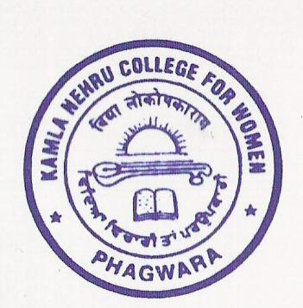

Phone : 01824-228229, 228137
KAMLA NEHRU COLLEGE FOR WOMEN, PHAGWARA – 144401
Distt. KAPURTHALA (Pb.)
AFFILIATED TO G.N.D.U. AMRITSAR
Accredited with Grade ‘A’ by NAAC with 3.55/4.00 CGPA
“College with Potential for Excellence” status by UGC

Paste latest PP Size Photograph
1. Application for the Post of :____________________________
2. Name (In Block Letters) :____________________________
3. Father/Husband’s Name :____________________________
4. Date of Birth as per (in figure) :____________________________
Matriculation Certificate(in words) :____________________________
5. Category General/SC/ST/OBC : ____________________________
6. Marital Status :____________________________
7. Address for Correspondence & :___________________________________
Telephone No. : ___________________________________
___________________________________
____________________________________
8. Academic Qualification
Examination | Year | Div/Marks Obtd.  Total Marks | % Marks  Obtd. | School/College | Board/ University
Matic
S.S. +2
B.A./B.Com/B.Sc./
M.A./M.Com./M.Sc
M.Phill./M.Litt/Ph.D
UGC NET
Any other

9. Experience if any:-
Institution you served as | Tenure  Period of Service | Scale/Emoluments | Total Length of experience
10. Games you play : -
Distinction if any
11. Co-Curricular Activities: -
Detail about your Participation
12. Any other Qualification.
13. Published Work (use separate sheet for detail)

Note: Please attach attested copies of all the certificates/degrees & detail Marks Card.
Use separate sheet for any additional information.

__________________
Signature of Applicant

